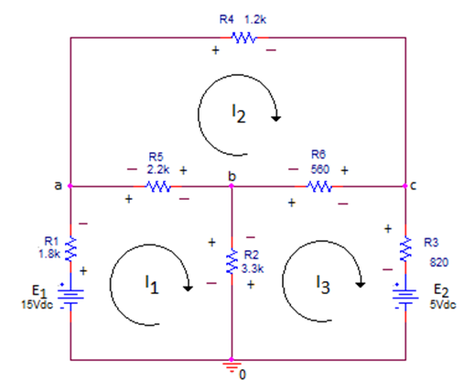

1. Find the loop currents I1, I2, I3
2. Use the loop currents to find: Va, Vb, Vc
3. What is the power supplied or absorbed by each source E1, E2? Explain.
4. What is the power absorbed by R1 and by R4?